Ethernet Standard Assignment

1. RJ-45 Connector Pin Layout (T568A & T568B)
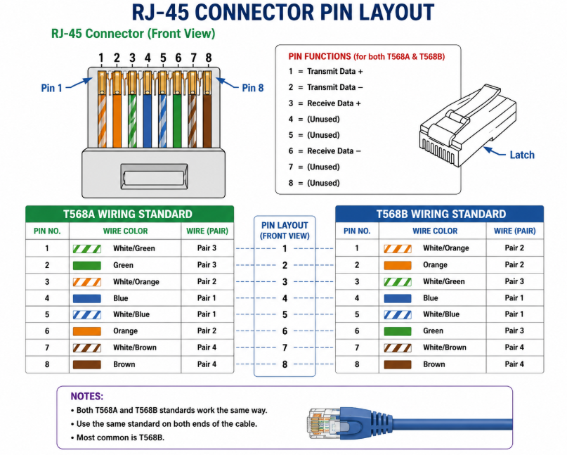

2. Comparison of Ethernet Standards
Standard | Speed | Cable Type | Max Length | Connector
10BASE-T | 10 Mbps | Cat3/Cat5 | 100 m | RJ-45
100BASE-TX | 100 Mbps | Cat5 | 100 m | RJ-45
1000BASE-T | 1000 Mbps (1 Gbps) | Cat5e/Cat6 | 100 m | RJ-45

3. Connecting Two Laptops Directly
To connect two laptops directly using Ethernet, a crossover cable is traditionally used. A crossover cable swaps the transmit (TX) and receive (RX) wires so the laptops can communicate directly. Many modern laptops support Auto-MDI/MDIX, which means a straight-through cable may also work automatically.

4. Devices That Use Ethernet
Device | Likely Standard | Reason
Desktop Computer | 1000BASE-T | Used for high-speed networking
WiFi Router | 1000BASE-T | Supports Gigabit Ethernet ports
Network Printer | 100BASE-TX | Enough for printing and file sharing

